Ruidong—Enterprise AI for Scenes: From "Testing Grounds" to "Production Lines" Total Evolution
While global attention remains focused on how "AI for Science" is reshaping the boundaries of scientific research, the second half of the enterprise-level large model competition has quietly shifted tracks.The transition from laboratory exploration in "AI for Science" to practical productivity in "AI for Scenes" —this is not merely a shift in technical focus; it marks the point where AI truly enters the "capillaries" of the enterprise. The Ruidong Agent Cloud Platform is dedicated to becoming the "enterprise AI scene testing ground" for this transformation, turning AI from a high-level concept into fully delivered digital labor .
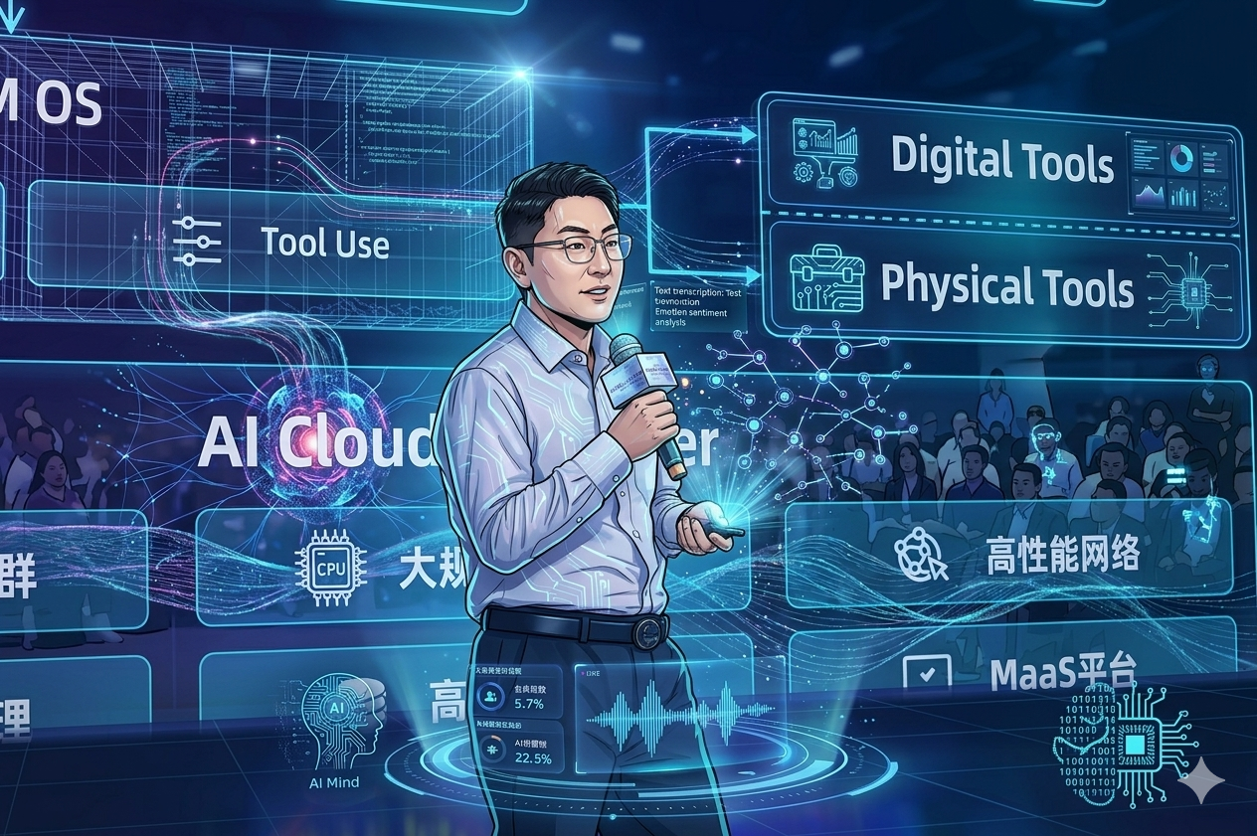

I. Scene as the Lifeline: Demonstrating Practical Power in the "Agent Square"
In Ruidong’s "Agent Square," AI is no longer a general-purpose model capable only of writing poetry; it is an execution expert deeply rooted in industry and precisely positioned for specific roles. These pre-set agents serve as the most intuitive evidence of "AI for Scenes":Financial Industry: Penetrating Regulatory Compliance and High-Efficiency Service To address the highly regulated nature of financial business, the square provides an Ontology-based penetrating regulatory agent , ensuring that penetrating compliance auditing is no longer an insurmountable manual burden. Additionally, the Due Diligence Assistant and Account Opening Assistant directly target frontline business operations, shortening processing cycles that originally took several days down to minutes.Energy Industry: Knowledge Empowerment and Equipment Mapping In the asset-heavy energy sector, the Equipment Management Assistant and Energy Knowledge Graph solidify the experience previously held only by veteran experts into digital assets, ensuring the safety and smart operation of production lines.Corporate Functions: "Digital Brains" for Finance and Legal Affairs The Financial Audit Assistant and Contract Audit Assistant achieve risk control verification in seconds, allowing daily enterprise operations to strike a balance between rigor and efficiency.
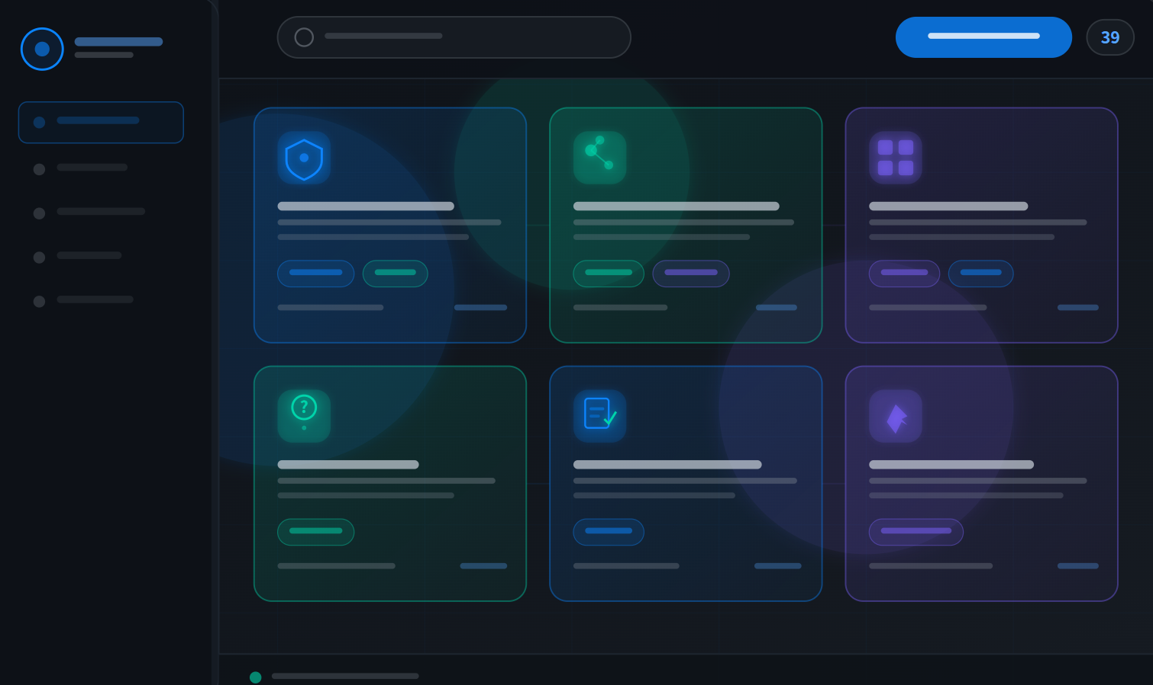

II. Business-side Driven: Empowering Those Who Know the Scene Best
The core logic of "AI for Scenes" is that those on the business frontline are always the ones to identify scene pain points.The Ruidong platform grants business-side customers unprecedented autonomy. Business personnel can fully leverage their domain know-how to develop agents directly through natural language in the "Intellectual Creation Workshop." This streamlined path from MVP (Minimum Viable Product) to total delivery breaks down the barriers between technical and business departments:
Rapid Stimulation : When employees discover that AI can truly solve long-standing pain points, such as report exporting or data comparison, their attitude toward AI shifts from "spectating" to "embracing."
Accelerating AI-native Processes : This decentralized innovation mechanism accelerates the construction of an "AI-native" organizational gene within the enterprise.

III. Industrial-grade Foundation: Safeguarding "Total Delivery"
If scene trials represent the "offense," then security and control represent the "defense." The Ruidong platform provides a solid, industrial-grade foundation for "AI for Scenes":Physical-level Security Trials : Utilizing micro-VM sandbox technology, the platform ensures every agent runs in an isolated environment, guaranteeing that data stays within the internal network.The "Fifth Report" for Quantitative Governance : Following the four traditional financial statements (such as the balance sheet), Ruidong introduces AI asset auditing. By providing token-level billing and ROI analysis, it ensures that every cent of AI investment yields a visible return within a specific scene.End-Cloud Synergy and the "Last 100 Meters" : Through the Ruidong Claw desktop client, cloud governance capabilities are extended directly to the employee's desktop. Whether for IM chats or document processing, AI remains on standby within native work scenarios, bridging the final gap of digital integration.
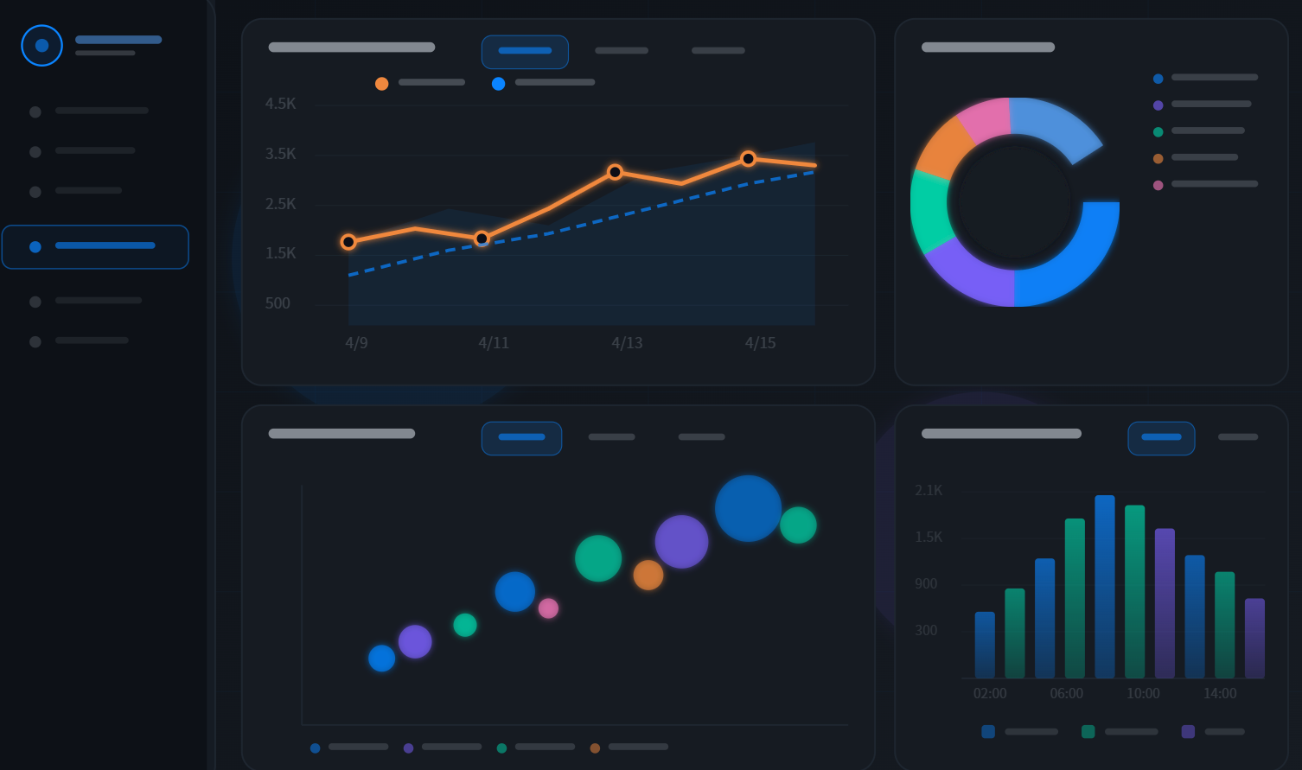

Conclusion
The evolution is moving from AI for Science in the laboratory to AI for Scenes in every business scenario.The Ruidong Agent Cloud Platform is helping the financial, energy, and various other sectors transform AI from an "expensive experiment" into a manageable, controllable, and auditable operating system . Here, every pain point is a spark for innovation, and every trial is a prelude to total delivery.Ruidong, letting AI grow in scenes, letting value bloom in practice.

